Status of This Document

Version History
Ver. No. | Date | Revised By | Description | Filename
1.0 | 2009-11-19 |  | First Draft | H2O In Maven v1.0.doc

Table of Contents

1. Status of This Document 2
1.1. Version History 2
2. Table of Contents 3
3. Introduction 4
3.1. Purpose of This Document 4
3.2. Target Audience 4
3.3. About Maven 4
4. H2O Project in Maven 5
4.1. Project Hierarchy 5
4.2. H2O Maven Life Cycle 5
4.2.1. mvn install in the h2o parent project 5
4.2.2. mvn jetty:run in the corvus project 6
5. Using Maven 7
5.1. Maven Installation 7
5.1.1. Windows 7
5.1.2. Linux 7
5.2. Maven Configuration 8
5.3. Check Out and Run Maven in command prompt for H2O 8
5.3.1. mvn clean 8
5.3.2. mvn install 8
5.3.3. mvn jetty:run 8
6. Eclipse Environment Setup 9
6.1. Eclipse Plugins Installation 9
6.1.1. subclipse 9
6.1.2. m2eclipse 9
6.2. Checkout the H2O Project from SVN 10
6.3. Run Maven commands in Eclipse 11
6.3.1. Simple Maven Commands 11
6.3.2. Run Configurations in Eclipse 12
7. FAQ 14

Introduction

Purpose of This Document
This document describes the H2O in Maven Project structure including the pom configuration and how developers create a working environment for H2O.

Target Audience
This document is written for System Architects and Developers before start working on the H2O in Maven.

About Maven
Maven is a project management tool on Java projects. The definition of Apache Maven: Maven is a project management tool which encompasses a project object model, a set of standards, a project lifecycle, a dependency management system, and logic for executing plugin goals at defined phases in a lifecycle.

H2O Project in Maven
For simplicity, Eclipse screenshots were captured for graphical illustration.

Project Hierarchy
h2o (Parent)
\
- corvus
- corvus-admin
- corvus-as2
- corvus-as2-admin
- corvus-as2plus
- corvus-as2plus-admin
- corvus-ebms
- corvus-ebms-admin
- corvus-main
- corvus-main-admin
- corvus-sfrm
- corvus-sfrm-main
- ebxml-pkg
- piazza-commons
- piazza-commons-extension

H2O Maven Life Cycle

mvn install in the h2o parent project
When running mvn install under ~/h2o, all child projects (Maven Modules) would be built independently in a sequence determined by the Maven Reactor automatically. This ensures the modules dependencies are ready for each module build.
And during each module build, the install life cycle will trigger the maven-antrun-plugin in the modules if there exists an antrun build configuration in the pom.xml. Currently, the ant action in the install phase will prepare all the necessary files for running the mvn jetty:run in the corvus child project.

mvn jetty:run in the corvus project
The is a maven command for running the maven-jetty-plugin in the corvus project. The jetty configuration can be found in ~/corvus/pom.xml. Please note that u have to run mvn install in for the h2o parent project before u can start the jetty in the corvus project.

Using Maven

Maven Installation

Windows
- Download the apache maven at http://maven.apache.org/download.html
- Extract the archive (Example: C:\Program Files\Apache Software Foundation\apache-maven-2.2.1)
- Add the following Windows Environmental Variable
  - M2_HOME – C:\Program Files\Apache Software Foundation\apache-maven-2.2.1
  - M2 – %M2_HOME%\bin
- Also append the %M2% in PATH
  - PATH – …;%M2%
- Open command prompt and type mvn -version to verify the installation

Linux
- Download the apache maven at http://maven.apache.org/download.html
- Extract the archive (Example: /usr/local/apache-maven-2.2.1)
- Run the following command to configure the Environmental Variable
  - export M2_HOME=/usr/local/apache-maven-2.2.1
  - export M2=$M2_HOME/bin
  - export PATH=PATH=$M2:$PATH
- Open command prompt and type mvn -version to verify the installation

Maven Configuration
After you have tried the mvn commands, a folder .m2 is created in the user home folder.
- Windows – C:\Users\ykyuen\.m2
- Linux – \home\ykyuen\.m2
Now, create a repository folder at there as well as copy the settings.xml from the M2_HOME to .m2 which is now your own maven configuration file.
The minimum mandatory setting is the local user repository. So add the following line in the settings.xml
Please refer to this settings.xml as an example.
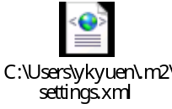

Check Out and Run Maven in command prompt for H2O
You can check out the Maven H2O at svn://147.8.178.160/H2O/branches/maven-h2o

mvn clean
Run this command under ~/h2o. It will clear all the maven built files in the h2o project and all its child projects.

mvn install
Run this command under ~/h2o. It will build the h2o project including the child projects. In addition, all the necessary files for running the h2o locally will be copied to /h2o/target/install. This command includes mvn clean.

mvn jetty:run
After running the above mvn install, run this command under ~/h2o/corvus. It will start the Jetty server and now the H2O is ready at http://localhost:8080/corvus/admin/home. To change the Jetty setting, please refer to the /h2o/corvus/pom.xml

Eclipse Environment Setup

Eclipse Plugins Installation

subclipse
Download Location: http://subclipse.tigris.org/update_1.4.x/
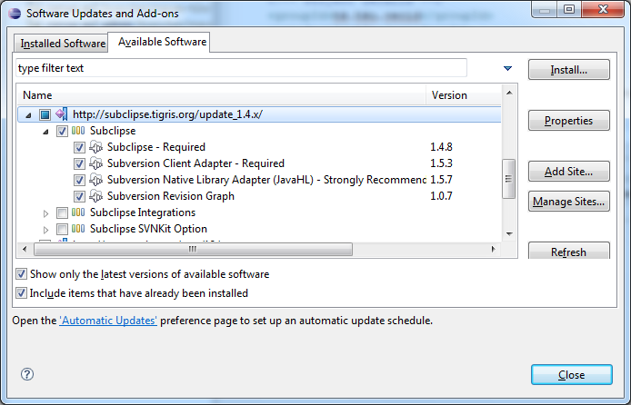

m2eclipse
Download Location: http://m2eclipse.sonatype.org/update
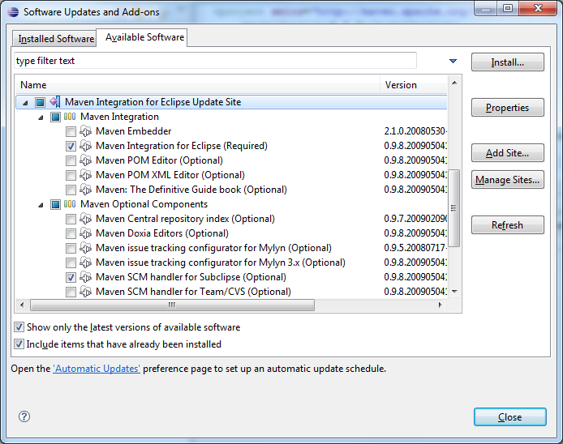

Checkout the H2O Project from SVN
Open the SVN Repository View
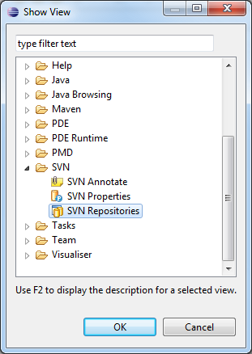

Check out as Maven Project
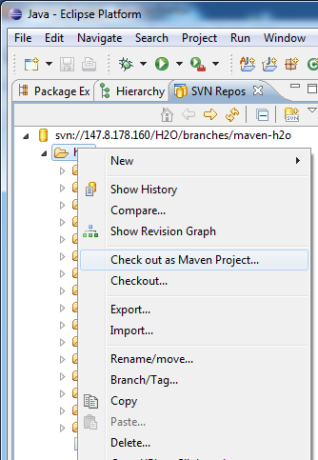

Changed the JRE of each projects from Eclipse default to JDK1.6
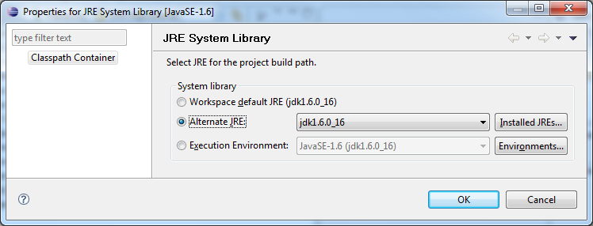

Run Maven commands in Eclipse

Simple Maven Commands
To run the maven commands, just right click the project and move the mouse pointer on Run As
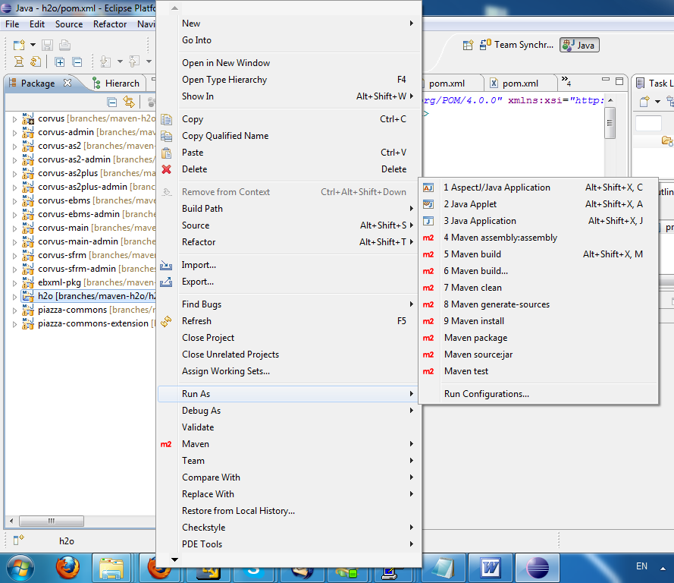

Run Configurations in Eclipse
You can configure your tailor-made Maven command in the Run Configurations. Please note that in order to run the mvn install in the h2o project and the mvn jetty:run in the corvus project. You have to make use of the Run Configuration and unchecked the Resolve Workspace artifacts.

The following 2 runs are all u need in order to start the h2o
Run: h2o install
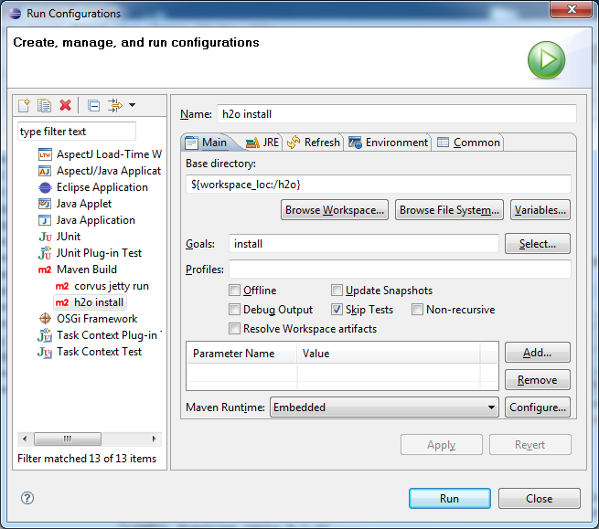

Run: corvus jetty run
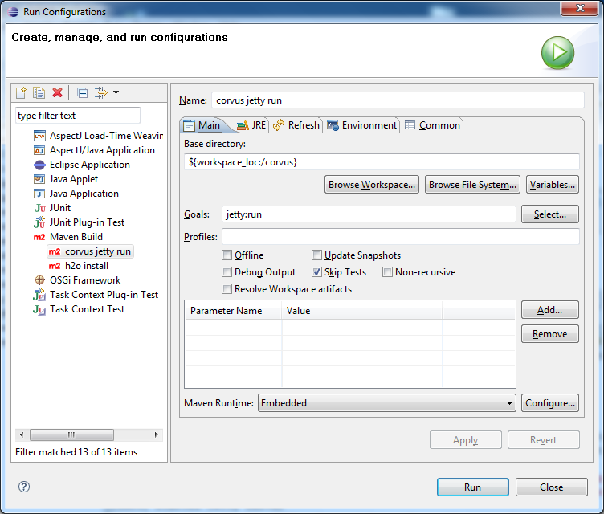

FAQ
Q. The corvus.log.properties.xml and corvus.properties.xml are out of synchronization after running the mvn install for the h2o project. But I didn’t make any changes to them. How come?
A. This is because after running the mvn install, these 2 files would be regenerated such that the <home> and <plugin> nodes will be changed according to your current project base directory.

